EDUCATION
ESPAE-ESPOL Guayaquil - Master’s Degree in Project Management (Graduate 2015)
University of Guayaquil - Bachelor’s Degree – Civil Engineering (Graduate 2000)
Certified in EEUU: Credential Evaluation and Authentication Report by World Education Services)

PROFESSIONAL DEVELOPMENT
License NJ Transit: Roadway worker, on track protection for contractor- November 2018
OSHA Construction 10 hours - February 2016
PMP Certification Preparation - July 2016.
Modern Design of Drinking Water Distribution System - July 2011
Project Management Institute NJ
OSHA, 30-Hour – Construction Safety and Health, 4/2021

EXPERIENCE
Mr. Plaza is a highly motivated Civil Engineer, has graduated in Ecuador with extensive experience in coordination of workers, materials, machinery in construction projects. He has prepared, monitored and executed project schedules. Mr. Plaza is proficient in:
• AutoCAD 2019
• MS Office
• Microsoft Project

Prior to joining KS Engineers, P.C. |  | Experience  (Months)
2020–2022: Project Manager at S&J Construction, LLC. In change of design, management, estimates, construction of buildings for general, renovation, and maintenance services of commercial or residential buildings. |  | ---
2019–2020: Assistant at Carminio Architecture, LLC. For the design, management, and construction of buildings and was involved with programming, codes and regulations, site and climate analysis, building technology, sustainability, costs, schedules, projects. |  | ---
2018–2019: Assistant at S&J CONSTRUCTION LLC. Underground specialist and utilities for commercial and residential customers: Was involved with all types of construction such as asphalt concrete paving, concrete paving, curbs, sidewalks, house basements, interior remodeling, repairs of concrete structures, excavations, slopes, retaining walls, placement of paving stones and foundations. |  | ---
2017–2018: Assistant at RENAISSANCE SECURITY for the installation of security cameras and fire protection system: commercial and residential. |  | ---
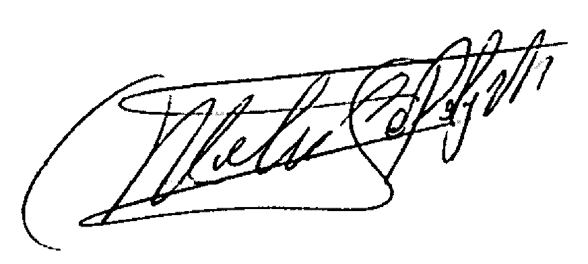  TOTAL RELATED EXPERIENCE | 0 Months
All statements in this resume are true and complete. 11/3/2023
(Signature)

